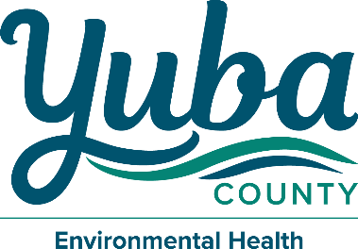
Mike Lee
Director – Community Development & Services Agency

Clark Pickell
Director – Environmental Health & CUPA

Government Center 915 8th Street, Suite 123
Marysville, California 95901-5273
(530) 749-5450 Fax (530) 749-5454

Owner Authorization for Permit Application & Issuance

Date:

Applicant Name:

Project Address:

City: State: Zip:

Permit(s) to be obtained:

Date:

Owner Name:

Owner Signature:

By signing this document, you are stating, 1. You are the current property owner and 2. You are giving permission to the person above, identified as the applicant, to obtain permit(s) on your behalf from the Yuba County Environmental Health Department.

